**Methodology**

To run the simulation, we used the Microsoft Excel Solver function to solve the problem with linear programming. There were two parts to the problem: to optimize the supply chain with a budget of CY 3 billion, and to see how much CO2 emissions we could cut down on with a budget increase of 10 percent. We used linear programming to solve this problem because linear programming is a great way to optimize solutions for business research. Linear programming allows for the most optimal answer that is also within the limitations presented in the problem.

Initial Optimization:

We used Microsoft Excel solver to find out which original design manufacturers (ODM) to order from and how many units of LCD TV sets to order from each ODM. We used a total of 72 decision variables, with 64 representing each specific ODM and transportation method combination (see appendix 1), and the other nine representing the decision to order from a specific ODM or not to. The 64 decision variables represent the potential amounts of units we assign to each decision node.

The objective function for this optimization was to minimize the sum of production costs and transportation costs for each of the 64 decision variables that represent a ODM and transportation method combination.

There are several limitations to this problem. The two most important ones are that we meet the demand for both the 42” LCD TV and the 32” LCD TV, which are 920,000 and 530,000 respectively. We need to also ensure that for each ODM that we decide to order from, there needs to be a minimum order of 200,000 units to engender the economies of scale, and also a maximum order of 600,000 units so we do not become dependent to that specific ODM. There is also the issue of keeping up with inventory, so there is a minimum order for each transportation method, as shown in table x. However, there are no limitations for shipping on water. Finally, we also need to keep all the costs below the budget of CNY 3 billion.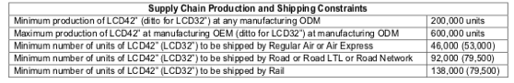Table x

Proposed Optimization:

We used Microsoft Excel Solver for this optimization as well to minimize the total CO2 emissions with the proposed new budget of CNY 3.3 billion. We kept the same decision variables from the previous problem because we still needed to know the total number of units shipped through each method, and also which ODM’s to order from for us to get our final solution.

However, the objective function is completely different from the previous problem. The point of this problem is to minimize the total CO2 emissions, so we calculated the emissions per single unit for both the 42” models and 32” models. We did this by multiplying the distance in kilometers from the specific ODM to the distribution center, by the CO2 emissions in kilogram per ton shipped per kilogram, and then multiplied that by the weight of each unit per metric ton (see appendix x). We took each corresponding value for each method and took the sum of products with the 64 decision variables to get the final value of the CO2 emissions.

The constraints for this optimization are the same as the previous problem with a couple more added. The new constraints are to keep the costs under CNY 3 billion and also to have an integer constraint on the decision variables to ensure that we are not shipping fractional units of the TV’s.

**Analysis and Findings**

Initial Budget

When running the optimization with the initial budget of CY 3 billion, we were able to determine which original design manufacturers (ODM) to order from and how many units we should order from each one. To satisfy the demand of 920,000 units for the 42” LCD TV sets, the conclusion is to order 320,000 units from ODM1 and 600,000 units from ODM4. To satisfy the demand of 530,000 units for the 32” LCD TV sets, it was best to order all 530,000 units from ODM1. All three of these orders comply with the minimum order of 200,000 units from one facility and the maximum order of 600,000 units from one facility (ODM1 and ODM2 are the only locations that can accommodate both 32” and 42” LCD TV models; both locations can accommodate the maximum order capacity for both the 32” and the 42” LCD TV models concurrently if needed).

The parameters for the minimum number of units shipped through regular air or air express for both the 32” and 42” models were met with all 53,000 units required for the 32” model shipped through regular air and all 46,000 units required for the 42” model shipped through regular air. The minimum number of units shipped through either road, road LTL, or road network were also satisfied. The minimum amount of 79,500 units for the 32” models was satisfied with all 79,500 units being shipped through road network, and the minimum amount of 92,000 units was satisfied through the road network as well. The minimum amounts of 79,500 units for the 32” model and 138,000 units for the 42” model using rail were both satisfied, with exactly the minimum being shipped. All the other units were delivered via water transportation.

The total cost for this operation came in under the budget at a cost of CY 2,999,985,597.10. When factoring in the amount of carbon dioxide emissions emitted through each shipping method (by multiplying the distance from each ODM to the distribution center, the carbon dioxide emissions for each shipping method, and the weight of each unit), the total carbon dioxide emissions for the operation was 7,425,340.87 kilograms.

Proposed Budget

The second optimization was done with the new proposed budget of CY 3.3 billion. The point of the new plan was to cut carbon dioxide emissions as much as possible within the new budget. Under the new plan, the 920,000 units needed to satisfy demand for the 42” model were ordered from three ODM’s. 200,000 units were ordered from both ODM1 and ODM4, and the remaining 520,000 units were ordered from ODM7. The 530,000 units needed to satisfy demand for the 32” model was all ordered from ODM2. All four of these orders satisfied both the minimum order amount of 200,000 units and the maximum order of 600,000 units.

The parameters for the minimum number of units shipped through regular air or air express for both the 32” and 42” models were met with all 53,000 units required for the 32” model shipped through regular air and all 46,000 units required for the 42” model shipped through regular air. The minimum number of units shipped through either road, road LTL, or road network were also satisfied. The minimum amount of 79,500 units for the 32” models was satisfied with all 79,500 units being shipped through road, and the minimum amount of 92,000 units was satisfied through road as well. The minimum amounts of 79,500 units for the 32” model and 138,000 units for the 42” model using rail were both satisfied, with exactly the minimum being shipped. All the other units were delivered via water transportation.

The total cost for this proposed operation came in at CY 3,266,029,761.60, under the proposed budget of CY 3.3 billion. The whole focus of this proposal is to minimize the amount of carbon dioxide emitted through the transportation of the LCD TV models. Under this plan, the total carbon dioxide emissions is 3,509,045.14 kilograms.

**Conclusion**

Based on our findings, we can substantially cut the carbon dioxide emissions of this specific consumer electronic company (CEC). To satisfy demand within the given parameters under the current budget of CY 3 billion, the carbon dioxide output by this operation is 7,425,340.87 kilograms. Under the proposed new budget of CY 3.3 billion

**Appendices**

**Appendix 1: Data Sheet**

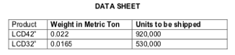

Table 1: This table shows the weight for each product and the demand for each product.



Table 2: This table shows the CO2 emission for each Kg per Ton-Km shipped for each method of transportation.

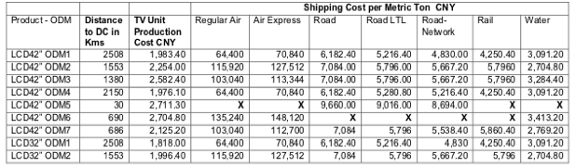

Table 3: This chart specifies the distances, production costs, and transportation costs for each specified decision variable.



Table 4: This chart shows the constraints that were laid out in the problem and also transferred onto the Microsoft Excel spreadsheet.

**Appendix 2: Excel Solver for Initial Optimization**

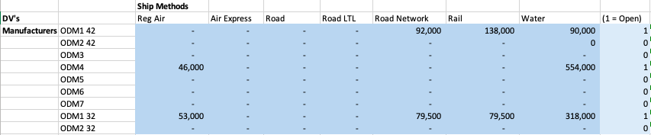

Table 1: Decision Variables; the last far right row indicates binary variables.

Objective Function: Minimize ∑ of (unit production cost i * Xij + unit weight in metric tons * ship cost ij * Xij) <unit weight in metric tons: 0.022 for 42”, 0.0165 for 32”>

Constraints used:

Kh*Yi – ∑ Xij >= 0 Kh = max capacity, i = Each ODM, j = shipping method

Kl*Yi – ∑ Xij <= 0 Kl = min capacity, Xij = units produced at ODM i shipped using method j

∑ of all DVs for 42” >= 920,000

∑ of all DV’s for 32” >= 530,000

Objective function <= 3 billion

∑ of DV’s for Rail for 42” >= 138,000

∑ of DV’s for Rail for 32” >= 79,500

∑ of DV’s for Reg Air and Air Express for 42” >= 46,000

∑ of DV’s for Reg Air and Air Express for 32” >= 53,000

∑ of DV’s for Road, Road LTL, and Road Network for 42” >= 92,000

∑ of DV’s for Road, Road LTL, and Road Network for 32” >= 79,500

(binary DV’s are excluded from all ∑ of DV’s)

**Appendix 3: Excel Solver for Proposed Budget**

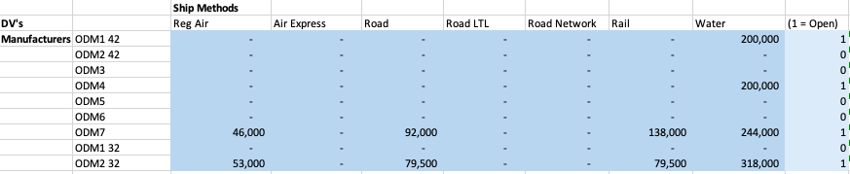

Table 1: Decision variables; the last far right row indicates binary variables.

Objective Function: